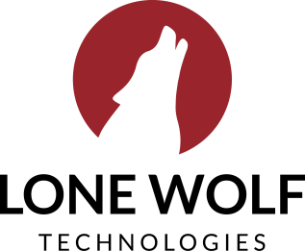
Authentisign + Forms
Transactions (zipForm Edition)

Subject: Introducing the new (and improved) eSignature and forms.
Body:
We know zipLogix Digital Ink® 2.0 powered by Authentisign is a mouthful, so we decided to simplify it—say hello to the new Authentisign! But it’s more than just a name change—it comes with major improvements to your eSignature.
Starting on [DATE], you’ll have access to upgrades for not one, but two of your favorite Transactions (zipForm Edition) features: eSignature and forms. The New Forms Editor and the New Authentisign make it simpler than ever to get your deals signed, sealed, and delivered with features and benefits that include:
- Better performance: Complete signings up to 60% faster with a new, intuitive workflow
- Better client experiences: Create and customize clauses for all your forms and offer clients simpler signings
- Better visibility: Get real-time insights into the status of all signatures, all in one place
- And so much more

CTA: Login and get started today!

Want to learn more about these new features? Check out our blog posts on the new Authentisign and the new Forms Editor.

Authentisign only
Transactions (zipForm Edition)

Subject: Introducing the new (and improved) eSignature.
Body:

We know zipLogix Digital Ink® 2.0 powered by Authentisign is a mouthful, so we decided to simplify it—say hello to the new Authentisign!

And it’s more than just a name change. Starting on [DATE], you’ll have access to exciting updates that make it simpler than ever to get your deals signed, sealed, and delivered. Features and benefits include:

- Better performance: Complete signings up to 60% faster with a new, improved workflow
- Better client experience: Create and send out signings that are intuitive and easy for clients to access from any browser or device
- Better visibility: Get real-time insights into the status of all signatures, all in one place
- And so much more
CTA: Learn more about the new features here.

